Michael Miranda

January 28, 2019

CSC 370-001

Bayer Filter

Technology, like digital cameras, utilize the Bayer Filter in order to construct an image taken from the real world. The Bayer Filter is an arrangement of red, green, and blue pixels in a grid pattern. The pattern consists of every other pixel being green and that red and blue pixels alternate rows. In order to reconstruct the image, each pixel looks at its vertical, horizontal, and diagonal neighbors so it can determine the values of the needed color channels. There are multiple methods to reconstruct the image. One method consists of, for example, one red pixel looking at the four green pixels that are above, below, left, and right of it and averaging them out and looking at the four blue pixels diagonal of the red pixel and averaging them out. Those two averages will correspond to the green and blue channels of the original red pixel.

I completed this project by first determining the necessary loops to iterate through the image in order to create the Bayer Filter pattern. I did not have much issue with that part of the project. The difficulty started during the process of reconstructing the image from the Bayer Filter. I originally was using the previous loops in order to loop through the specific red, green, and blue pixels from the Bayer Filter, however this produced many different types of filtered images that did not look like the original image. I ended up scrapping that idea and used a different method that I had found doing some research on the reconstruction process. This method takes a group of four pixels(one red, two green, and one blue) and takes the red value, the blue value, and the average of the two green pixels and applies them to the group. This method produced a reconstructed image that looks similar to the original.

Resulting Images:

Image 1

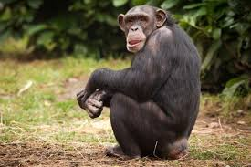 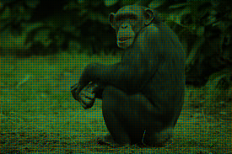

Original Image Bayer Filter

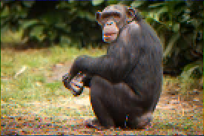

Reconstructed Image

Image 2

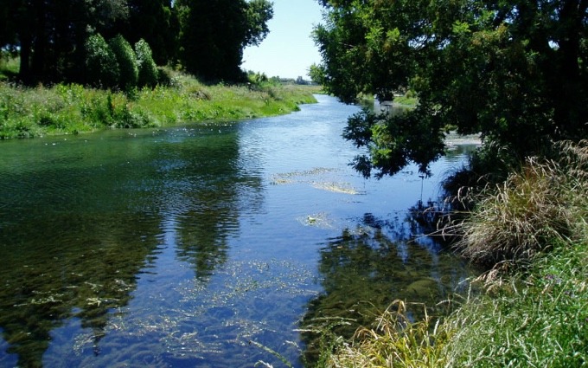 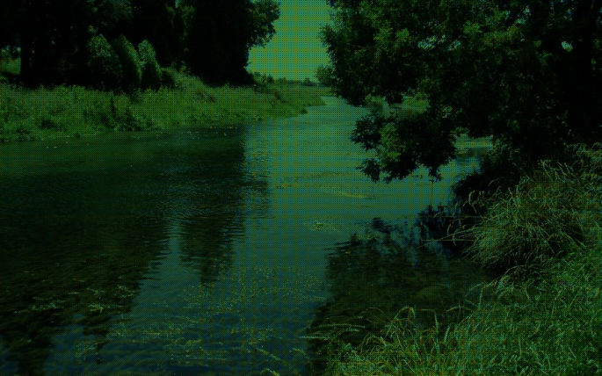

Original Image Bayer Filter

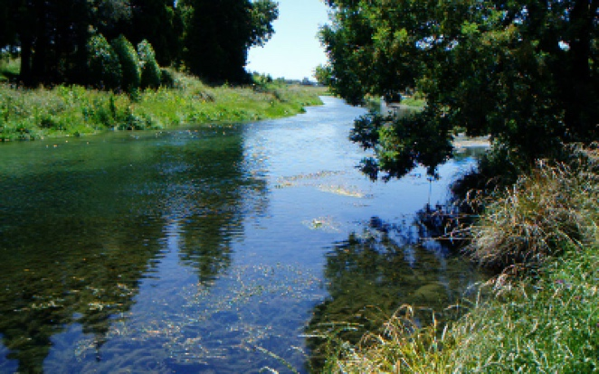

Reconstructed Image

Image 3

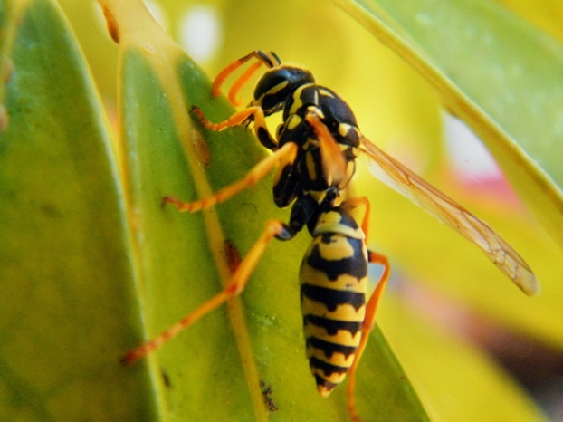 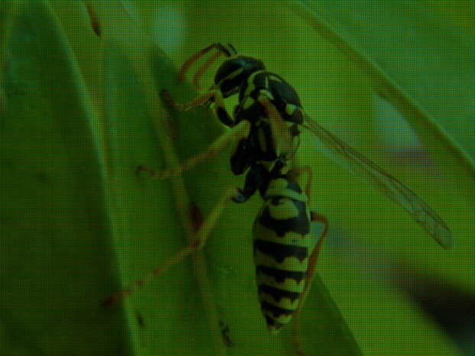

Original Image Bayer Filter

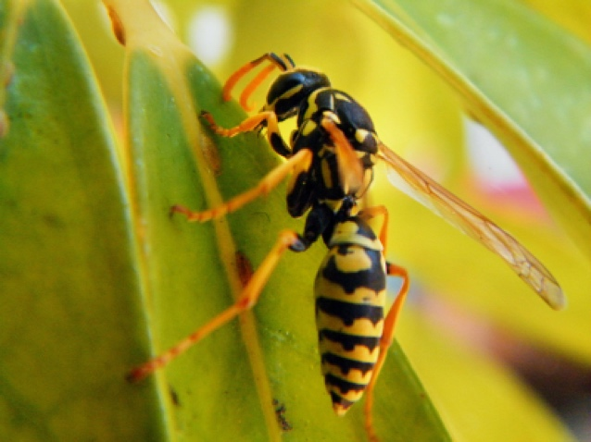

Reconstructed Image